Index Number………..
THE UNITED REPUBLIC OF TANZANIA
PRESIDENT’S OFFICE REGIONAL ADMINISTRATION AND LOCAL GOVERNMENT
KAGERA REGION
FORM TWO MOCK ASSESSMENT, MAY 2020
041 BASIC MATHEMATICS
TIME: 2:30HOURS
INSTRUCTIONS
- This paper consists of ten (10) questions
- Answer all questions in the spaces provided
- Show clearly all necessary working
- Where necessary mathematical tables may be used
- Cellular phones, calculators and any unauthorized materials are not allowed in examination room
- Write your index number at the top right corner of every page

FOR EXAMINERS’ USE ONLY
QUESTION | SCORE | EXAMINER’S INITIALS
TOTAL
CHECKER’S INITIALS

- Re-arrange the digits in the number 391587 to form the largest and smallest possible numbers.

- (a) Given that x² + 8x + T = (x + B)² Find the value of T and B

(b) Find the value of n if ()^{n-1} = ()^{2n}

- Find the size of the angle marked “a” in the figure below:

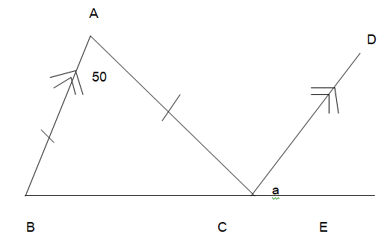

- (a) Find the time in which Tsh 400,000 will earn Tsh. 96,000 at the rate of 12%

(b) What is the product of LCM and of GCF of 16,24 and 36

- (a) Given (x+40°) and (2x +5°) are complementary angles, find the value of x.

(b) Rationalize the denominator to the simplest form
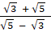

- (a) Factorize the expression 6x² - 11x + 4 by splitting the middle term.

(b) By using elimination method solve for x and y in
4y – 41 = -14x
6x = 30 – 10y

- (a) If =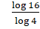 Find the value of b

(b) By using mathematical table evaluate
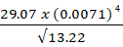

- (a) The line passed through the point A(2,y) and (5,7) have the slope of . What is the value of y?

(b) What is the centre of an enlargement, given that the image of A(3,2) under the enlargement scale factor 2 is A’ (6, 4)?

- In a class of 60 students 47 are taking physics while 33 are taking Mathematics. If there are 2 students who are taking neither Physics nor Mathematics and 22 are taking both Physics and Mathematics
- Represent this information by Venn diagram.

- How many students are taking mathematics only?

- The following are the Mid-term test marks of 80 form two Mathematics students from Mtoni Secondary School.

Marks in % | 25 | 35 | 45 | 50 | 65 | 75 | 80 | 85
Number of students | 14 | 18 | 11 | 10 | 5 | 14 | 2 | 6

- Which mark was scored by largest number of students?

- Which mark was scored by smallest number of students?

- What is the difference between the number of students passed the test and those who failed if the pass mark was 50%

